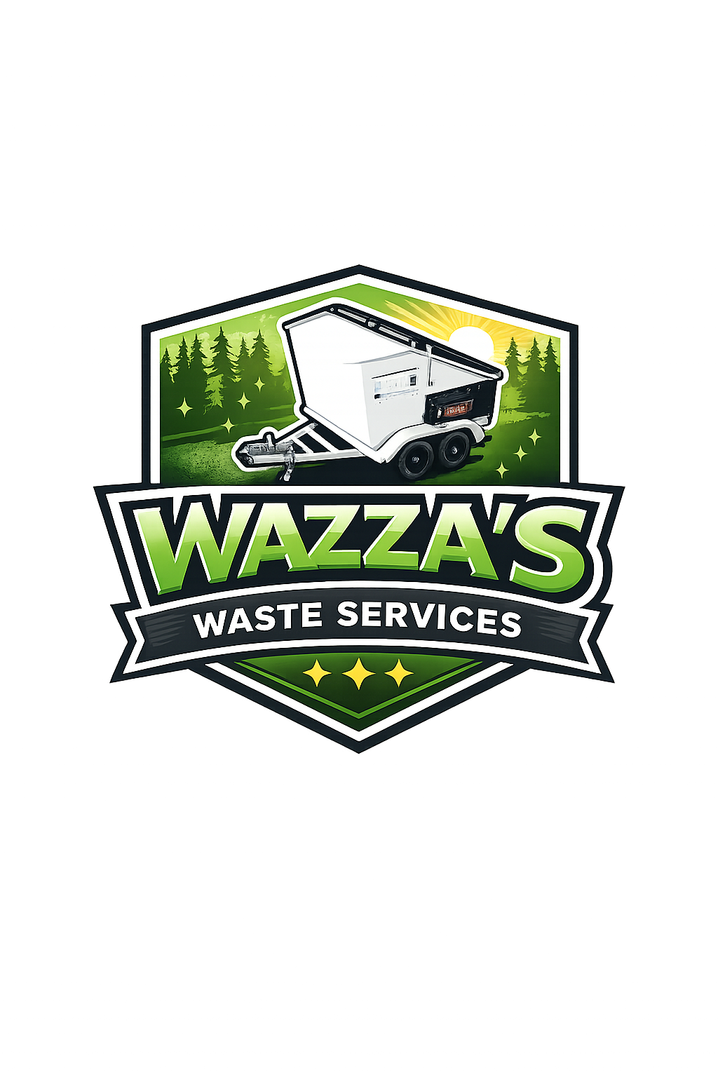
WAZZA’S WASTE SERVICES
SKIP TRAILER HIRE AGREEMENT
This agreement sets out the terms and conditions for the hire of the skip trailer from Wazza’s Waste Services.

Business Details
Business Name: Wazza’s Waste Services
ABN: 57 666 000 657
Phone: 0419 711 577
Email: wazzaswaste@gmail.com

Customer Details
Full Name: ________________________________________________________________
Driver Licence Number: ____________________________________________________
Residential Address: _______________________________________________________
Phone Number: ___________________________________________________________
Email Address: ____________________________________________________________

Hire Information
Hire Start Date & Time: ___________________________________________
Hire End Date & Time: ____________________________________________
Trailer Registration Number: ______________________________________
Bond Paid: ______________________________________________________
Hire Fee Paid: ___________________________________________________
Delivery/Pickup Address: ____________________________________________________________
____________________________________________________________________________________

Accepted Waste Types
✓ General Household Waste
✓ Green Waste
✓ Furniture
✓ Cardboard & Packaging
✓ Renovation Waste (light)

Prohibited Waste
✗ Asbestos
✗ Chemicals or Hazardous Waste
✗ Paints & Oils
✗ Gas Bottles
✗ Batteries
✗ Tyres
✗ Liquid Waste
X Soils and Rocks
✗ Explosives or Flammable Materials

Pricing Guide
24 Hour Hire: $390
Weekend Hire: $480
Weekly Hire: $650
Extra Weight Charges Apply
Late Return Fee: $50 per day
Cleaning Fee (if required): $80
Commercial Construction & Demolition waste will incur additional charges, please enquire for an individual quote.

Terms & Conditions
1. The trailer remains the property of Wazza’s Waste Services at all times.
2. The customer is responsible for the trailer during the hire period.
3. The customer must not overload the trailer beyond the marked fill line /so lids close, which is approx. ½ ton (500kg).
4. Additional fees may apply for prohibited waste, excessive weight, damage, or cleaning.
5. The customer agrees not to place prohibited waste into the trailer.
6. The trailer must be returned in the same condition it was hired.
7. Late returns may incur additional charges.
8. Loose items to be bagged. Bags supplied.
9. Wazza’s Waste Services reserves the right to refuse collection of unsafe or overloaded trailers.

Condition Report
Tyres Checked: Yes / No
Lights Checked: Yes / No
Existing Damage: ___________________________________________________________________
Photos Taken Before Hire: Yes / No

Customer Declaration
I confirm that the information provided is correct and I agree to the terms and conditions of hire.

Customer Signature: ____________________________________________
Date: __________________________________________________________

Business Representative Name:_______________________________________________________
Business Representative Signature: ___________________________________________________
Date: _____________________________________________________________

